Special Families East Grinstead Library

Children’s Books

We have a number of children’s books in our library. We have listed these in four main categories:
- Feelings, emotions and social understanding
- Toilet training
- Titles relating to specific conditions
- Signing

Some titles can either be read to a child or older children can read them on their own. Others are designed for an adult to work with the child to discuss possible scenarios or complete activities. We hope that the short synopsis we have added against each book will help you decide which titles may be appropriate for your child. Please note that the synopsis has been cut and pasted from where these books are sold and do not represent the opinions of Special Families East Grinstead.

Feelings, Emotions and Social Understanding

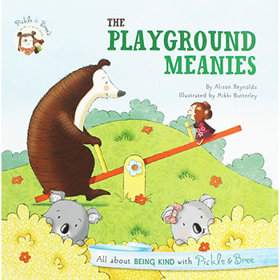 | The Playground Meanies, All about being kind, Alison Reynolds  Pickle and Bree are spending a day outdoors with their good friend, Jason. They’re excited to explore the playground, and are even more excited about making some new friends―until they meet two little bears who are not very friendly at all! How will Pickle and Bree deal with the playground bullies?  - Great new titles in a popular series which gently teaches children to explore the skills needed to successfully manage relationships with their friends and family.  - Simple, humorous narratives allow plenty of room for discussion between adults and young readers.  - Beautifully illustrated with personable characters that children will connect with. Handy Guide to Good Deeds at the back of the book.
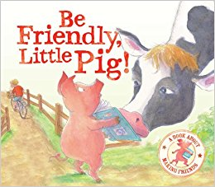 | Be Friendly Little Pig, a book about making friends, Tiziana Bendall-Brunello  Little Pig finds a book lying in the farmyard. He wants a friend to show him how to read it. Can the other animals help him? Will the little boy be his friend? This book is to help young children understand more about making friends.
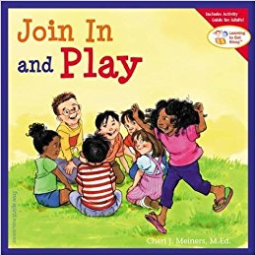 | Join In and Play, Cheri Meiners  It’s fun to make friends and play with others, but it’s not always easy to do.  You have to make an effort, and you have to know the rules—like ask before joining in, take turns, play fair, and be a good sport. This book teaches the basics of cooperation, getting along, making friends, and being a friend.  Includes ideas for games adults can use with kids to reinforce the skills being taught.
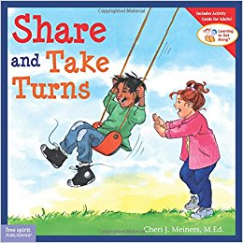 | Share and Take Turns, Cheri Meiners  Explains what sharing means and provides examples of different ways that two people can share what they both want, such as taking turns, dividing things, or playing together. Includes information and extension activities for parents or teachers.
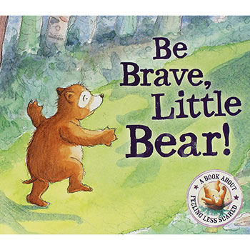 | Be Brave Little Bear, a book about feeling less scared, Tiziana Bendall-Brunello  "I'm so tired," yawns Little Bear, but still he cannot get to sleep. The woods at night are filled with such strange noises and scary shapes. "Ooooh!" cries Little Bear as a large shadow appears. This is a brilliant book to help young children feel less scared.
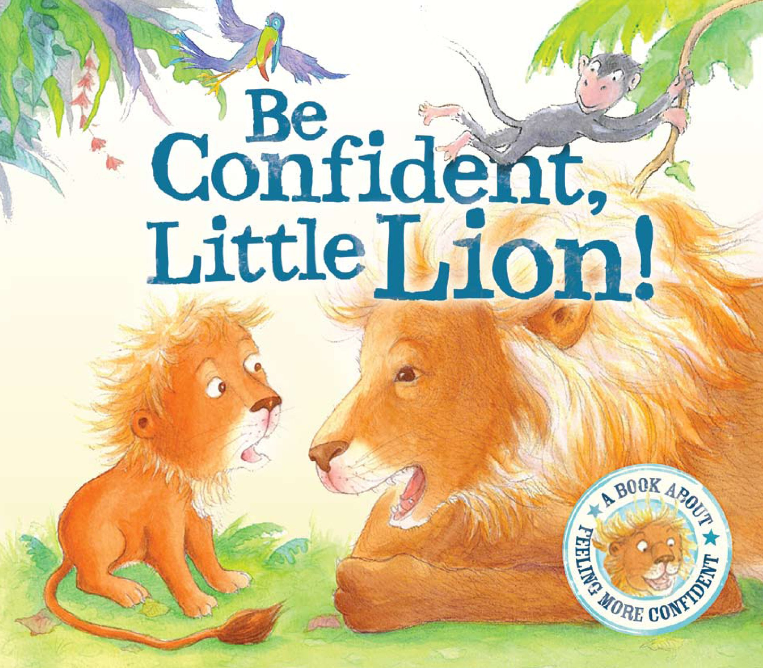 | Be Confident Little Lion, a book about feeling more confident, Tiziana Bendall-Brunello  When Mummy and Daddy Lion ROAR out loud, Little Lion only squeaks. And he isn't happy about it. But then along comes a helpful mouse who cares. This is a book to help young children feel more confident.
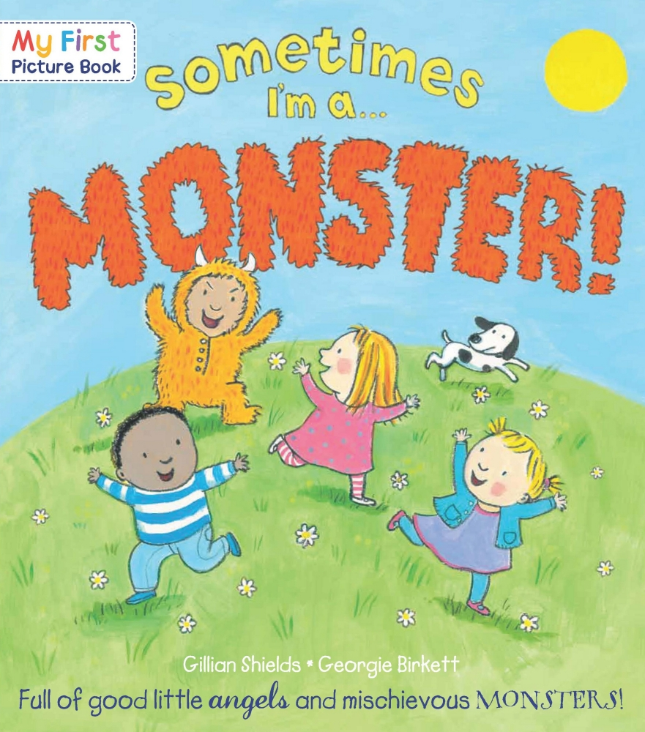 | Sometimes I’m a Monster, Gillian Shields and George Birkett  “Sometimes I'm an angel, helpful, sweet and kind.  But sometimes I'm a MONSTER with mischief on my mind!”  Award-winning illustrator Georgie Birkett brings to life these four lovable friends as they show that every child has a monster, as well as a little angel, inside them. This is a witty look at good and bad manners, full of warmth and humour.
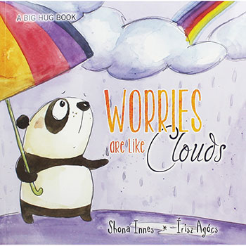 | Worries are Like Clouds, Shonna Innes and Irisz Arocs  Worries are Like Clouds compares worries to the weather, acknowledging that some days are wonderful, filled with golden sunlight that calls us outside to run and jump and play with fresh air on our faces. But some days are not so wonderful and can be a bit tough.  The Big Hug series deals with emotive issues that children face in direct and gentle terms, allowing children’s feelings and problems to be more easily shared and discussed with family and friends.  Author Shona Innes is a qualified clinical and forensic psychologist with many years of experience assisting children in times of trouble.
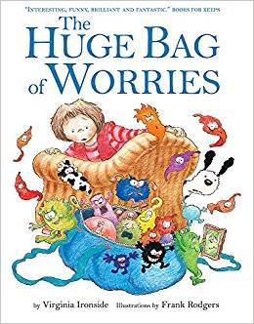 | The Huge Bag of Worries, Virginia Ironside & Frank Rodgers  Wherever Jenny goes, her worries follow her - in a big blue bag. They are there when she goes swimming, when she is watching TV, and even when she is in the lavatory. Jenny decides they will have to go. But who can help her?  The Huge Bag of Worries was written by Virginia Ironside, one of Britain's leading agony aunts, and has sold 140k copies to date.  'This book can be read millions of times when you are worried.' - Books for Keeps  A compelling picture book which can be used as a spring board into what worries children today.
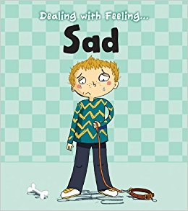 | Dealing With Feeling...Sad, Isabel Thomas  This book, part of the Dealing with Feeling series, looks at sadness. Topics covered within the book include what it feels like to be sad, how to stop being sad, and how to help other people who might be feeling sad.
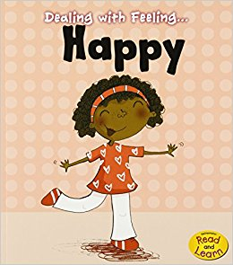 | Dealing With Feeling...Happy, Isabel Thomas  Each book in the "Dealing with Feeling..." series looks at a different emotion commonly experienced by young children. The books help readers to identify their emotions, and provide tips and advice on how best to express and deal with them. This book looks at happiness, including what happiness feels like, how to turn sad feelings into happy ones, and how to make other people feel happy.
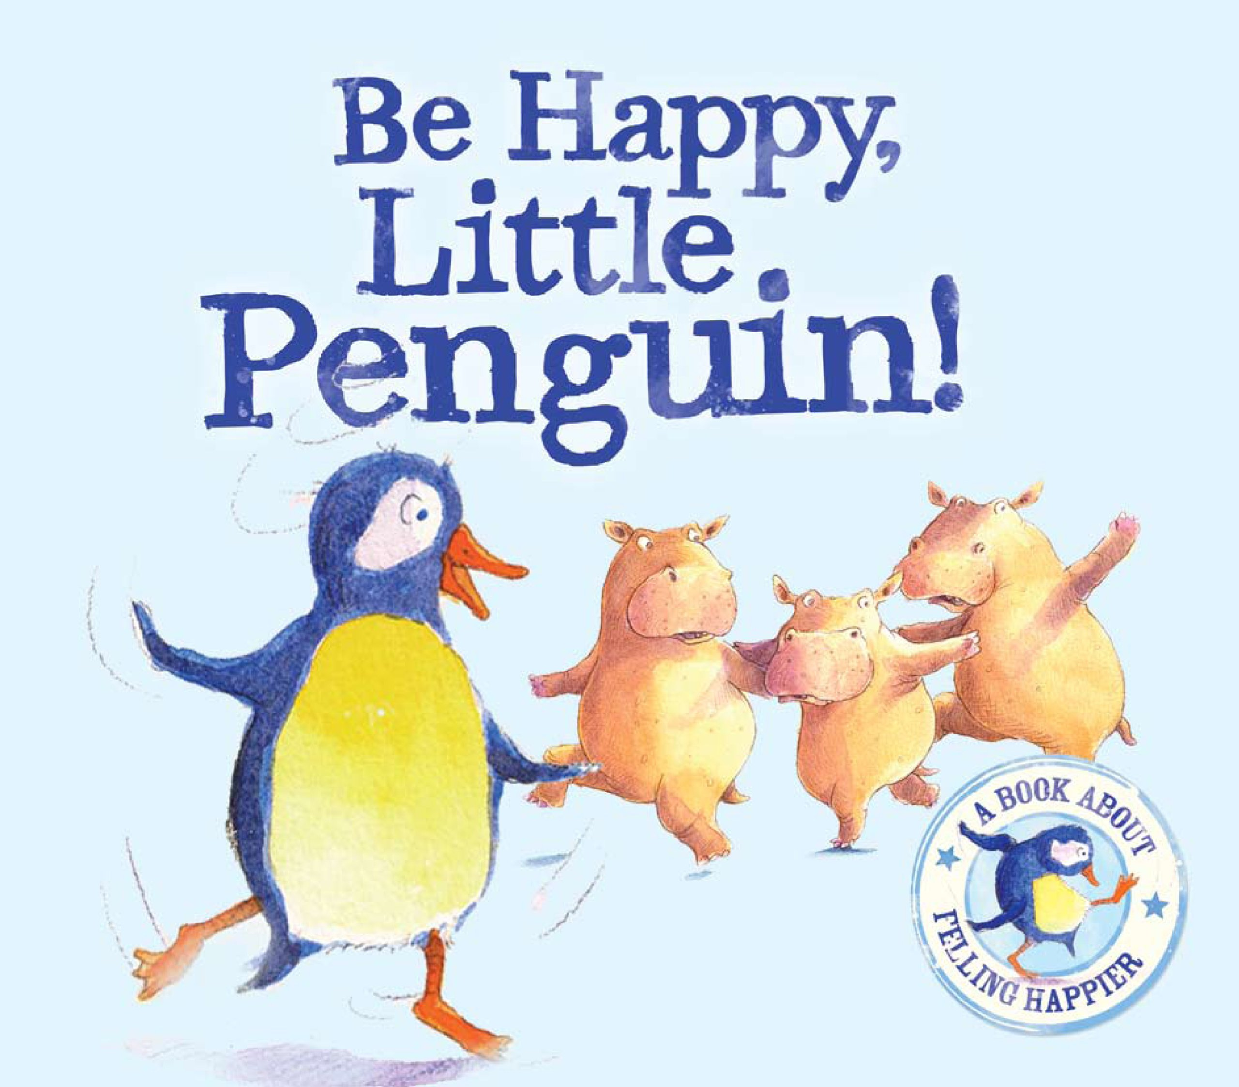 | Be Happy Little Penguin, a book about feeling happier, Tiziana Bendall-Brunello  Little Penguin would love to twirl like a graceful ballerina, but he can't get the hang of dancing. But then he tries a brand-new dance... and everyone wants to copy it!
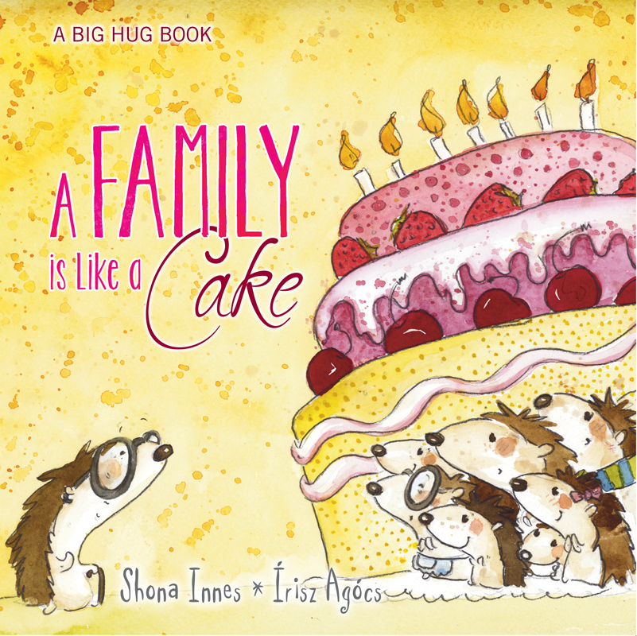 | A Family is Like Cake, Shonna Innes and Irisz Arocs  Cakes are made from many different ingredients to create something unique, delicious and amazing. A family is a lot like a cake. Families come in all shapes and sizes. They are the people who help us feel that we belong. Families give us help, support and love... even when we are apart from them. When we are with our family, we feel like we are home.  The Big Hug books grew out of letters sent to children and their families after their psychology sessions. Each book has its origins in a real need for a real child with a real problem and offers real strategies from a real psychologist. The heart-felt illustrations and simple words aim to simplify tricky situations and soothe strong emotions. The books aim to give children, and the people who care for them, a way to talk about problems. The Big Hug books acknowledge that some moments in life are tricky and encourage acceptance, problem solving and help-seeking as needed.
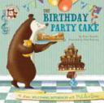 | The Birthday Party Cake, All about welcoming differences, Alison Reynolds  Pickle and Bree are the very best of friends, though they don’t always see eye to eye! They may have their differences, but together, they always manage to work through their problems. Featuring a handy Guide to Good Deeds at the back of each book, parents and children can join Pickle and Bree on their adventures while gently exploring social etiquette and positive behaviour.  In The Birthday Party Cake, it’s Jason’s birthday and Pickle is planning a special bear birthday surprise for his friend. He knows exactly the kind of cake to make, and the perfect bear games to play. But when Bree decides to lend a hand, her idea of a perfect party is not exactly what Pickle had in mind!  Can Pickle and Bree find a way to save Jason’s birthday?
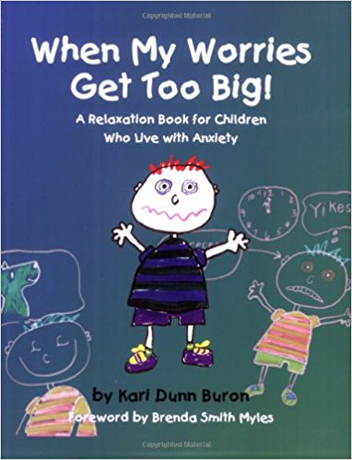 | When My Worries Get Too Big!: A Relaxation Book for Children Who Live with Anxiety, Kari Dunn Buron  More than any other issue, 'losing control' can cause major problems for children. Through the irresistible character of Nicholas, this book gives young children an opportunity to explore with parents or teachers their own feelings as they react to events in their daily lives while learning some useful relaxation techniques. Children who use the simple strategies presented in this charming book, illustrated by the author, will find themselves relaxed and ready to work or play.
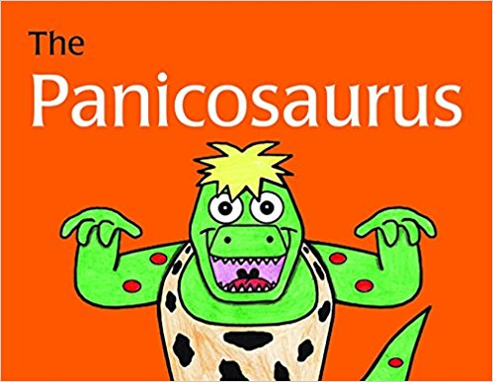 | The Panicosaurus, Kay Al-Ghani & Haitham Al Ghani  Have you ever felt a sense of dread and worry creeping over you?  That might be the Panicosaurus coming out to play…  Sometimes the Panicosaurus tricks Mabel's brain into panicking about certain challenges, such as walking past a big dog on the street or when her favourite teacher is not at school. With the help of Smartosaurus, who lets her know there is really nothing to be afraid of, Mabel discovers different ways to manage Panicosaurus, and defeat the challenges he creates for her.  This fun, easy-to-read and fully illustrated storybook will inspire children who experience anxiety, and encourage them to banish their own Panicosauruses with help from Mabel's strategies. Parents and carers will like the helpful introduction, explaining anxiety in children, and the list of techniques for lessening anxiety at the end of the book.
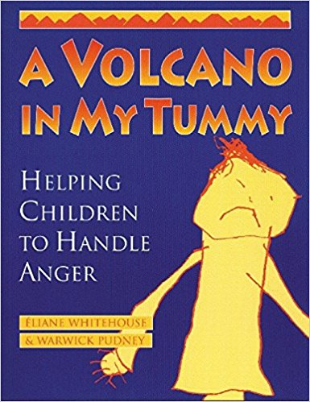 | There’s A Volcano In My Tummy, Elaine Whitehouse & Warwick Pudney  A Volcano in My Tummy: Helping Children to Handle Anger presents a clear and effective approach to helping children and adults alike understand and deal constructively with children's anger. Using easy to understand yet rarely taught skills for anger management, including how to teach communication of emotions, A Volcano in My Tummy offers engaging, well-organized activities which help to overcome the fear of children's anger which many adult care-givers experience. By carefully distinguishing between anger the feeling, and violence the behavior, this accessible little book, primarily created for ages 6 to thirteen, helps to create an awareness of anger, enabling children to relate creatively and harmoniously at critical stages in their development.  Through activities, stories, articles, and games designed to allow a multi-subject, developmental approach to the topic at home and in school, A Volcano in My Tummy gives us the tools we need to put aside our problems with this all-too-often destructive emotion, and to have fun while we're at it.
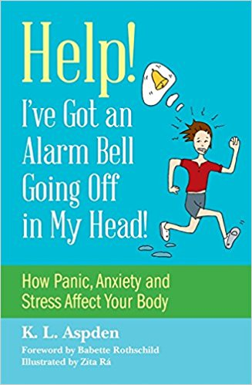 | Help! - I've got an alarm bell going off in my head!, KL Aspden  Ever wondered what happens inside our bodies when we feel angry, nervous, stressed or anxious? This straightforward, illustrated guide explores just that, explaining what happens to the brain and nervous system when that alarm bell in our heads starts ringing. It describes how our bodies can become very sensitive and set off false alarms, and includes tips and activities to help you reduce feelings of anxiety and keep your nervous system healthy.  Designed for ages 9+, the book aims to teach children who suffer from anxiety, stress or anger about the fight, flight or freeze response in their bodies and what can trigger it, and helps them to understand that it is something that everyone experiences. It also includes ways to manage the stress reaction and reduce feelings of shame. It is an invaluable resource for anyone supporting children who are easily triggered into anxiety or anger, including parents and carers, support workers, teachers, and therapists.
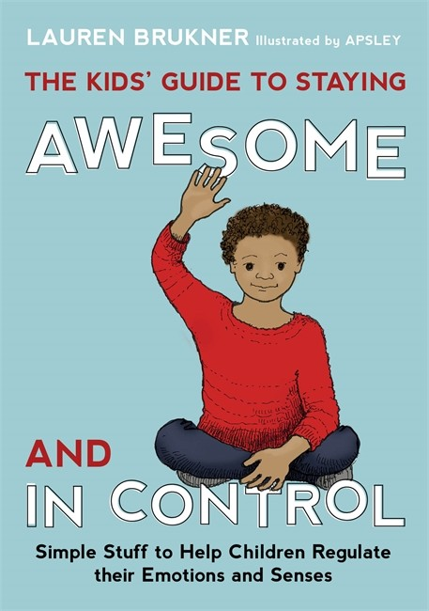 | The Kids' Guide to Staying Awesome and In Control, Lauren Brukner  Packed with simple ideas to regulate the emotions and senses, this book will help children tackle difficult feelings head-on and feel awesome and in control!  From breathing exercises, pressure holds and finger pulls, to fidgets, noise-reducing headphones and gum, the book is brimming with fun stuff to help kids feel cool, calm and collected. They will learn how to label difficult feelings, choose the perfect strategies and tools to tackle them, and use these correctly whether at home or at school. The strategies and tools are accompanied by cartoon-style illustrations, and the author includes useful tips for parents and teachers as well as handy visual charts and checklists to track learning and progress.  Armed with this book, kids will be well on their way to managing difficult emotions and feeling just right in whatever situation life throws at them! Suitable for children with emotional and sensory processing difficulties aged approximately 7 to 14 years.
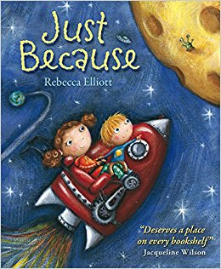 | Just Because, Rebecca Elliott  'My big sister Clemmie is my best friend. She can't walk, talk, move around much, cook macaroni, pilot a plane, juggle or do algebra. I don't know why she doesn't do these things. Just because.'  Just Because tells of a brother's love for his sister. He is so enthusiastic about just how loving and special she is, and delights in telling us about all the fun things they do together. Only as his tale unfolds does the reader begin to realise that his sister has special needs and by then we just accept as he does all the wonderful things about her. Rebecca Elliot's heart-warming picture book, much celebrated for its touching and sensitive approach to introducing the issue of disability to young children through a charming celebration of sibling friendship.
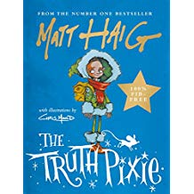 | The Truth Pixie, Matt Haig  Wherever she is, whatever the day,  She only has one kind of thing to say.  Just as cats go miaow and cows go moo,  The Truth Pixie can only say things that are true.'  A very funny and lovable tale of how one special pixie learned to love herself. The Truth Pixie is an enchanting, rhyming story that will delight younger readers.

Toilet Training

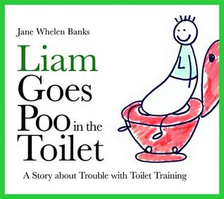 | Liam goes poo in the toilet, Jane Wheelan-Banks  "This is Liam. Every day Liam eats lots of good food. Each time Liam eats, his tummy gets fuller and fuller… and fuller… until Liam's tummy starts to stretch"  Successful toilet training is a time of celebration for both parents and child. It marks the end of dirty diapers and a forward step in the development of a child. Fraught with both stress and triumph, the period of toilet training can take from days to months. For a typical child, learning to gain control over the body's internal stimuli can be at best challenging. For many children, however, these internal cues can be overwhelming and confusing, leading to both a frustrating and traumatic toileting experience.  Liam Goes Poo in the Toilet illustrates the relationship between eating and excreting. It provides visual instructions on how to "relax and push". After much fanfare, Liam finally masters going 'poo' in the toilet, and both he and Mum bask in the glory of a job well done.
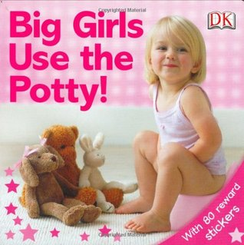 | Big Girls Use The Potty!, Andrea Pinnington  Take the worry out of potty training with this fun and informative guide that encourages your child to use the potty like a big girl. Now your child can be potty perfect with this step-by-step guide to using the potty with pride! With lots of friendly advice, and special reward stickers to encourage success, soon your toddler will be able to say, "Bye-bye, diapers!" With rhyming text, this book is fully illustrated and complete with a pull-out chart and star stickers. The emphasis is on motivating children to use the potty correctly by giving them praise and rewarding their success as they take their first steps towards becoming diaper-free. This book is a great introduction to a challenging family subject. Motivating and fun! Includes 80 reward stickers for your brave little trouper. Practice makes perfect!
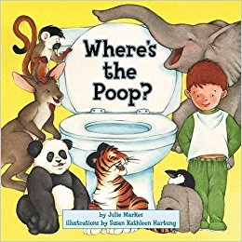 | Where's the Poop?, Julie Markes & Susan Kathleen Hartung  This engaging and sweet, funny lift-the-flap book shows children that all creatures have a place to poop: tigers in the jungle, kangaroos in the outback, and monkeys in the rain forest.  With the aid of this playful book, your child will see that he or she has a place to poop, too. While reinforcing the concept of toilet training, Where's the Poop? gives children the confidence they need.  For each animal, there are three flaps. On the tiger spread, for example, the tiger says, "My playful cub, did you make a poop?" "Yes, Daddy," replies the cub. "And now I feel much better." The child lifts the flaps and sees mommy tiger in a swimming hole, then his playful big brothers...and with the third flap, "There's the poop!"
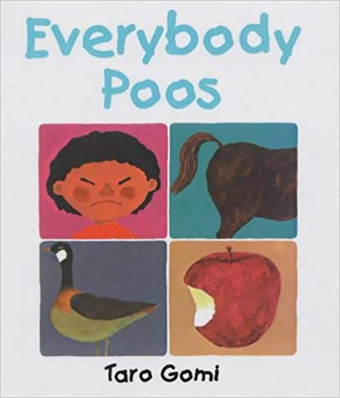 | Everybody Poos, Taro Gomi  All living things do different sorts of poo. Some are different colours, others have different smells or sizes. Some do it on land, some poo in water. Some poo in a toilet, or in a potty, or in their nappies. Taking a no-nonsense approach to the bodily function, this important picture book helps encourage children not to be ashamed about potty training, reassuring them that everybody poos!

Titles relating to specific conditions

Acquired Brain Injury

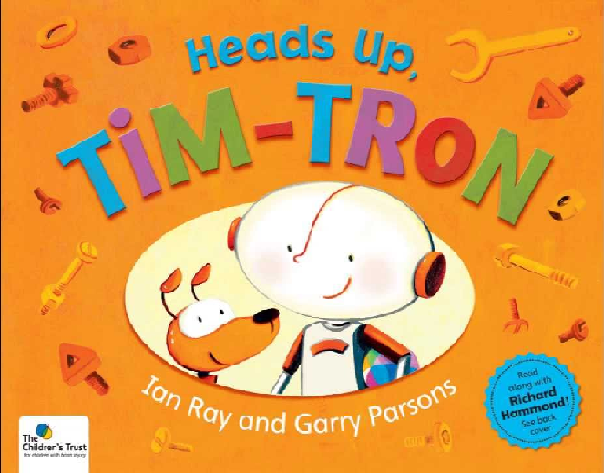 | Heads-up Tim-Tron, Ian Ray and Gary Parsons for The Children’s Trust  Written for any children who’d like to know more about acquired brain injury, Tim-Tron’s story explains the condition by placing it in a world of mechanical marvels.  This book is full of practical ideas to help children (and maybe some parents) understand and manage brain injury.  Tim-Tron has been produced by The Children’s Trust, and draws on three decades of experience working with children with acquired brain injury.

ADHD

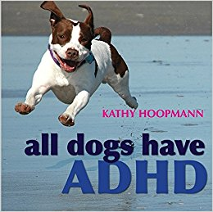 | All Dogs have ADHD, Kathy Hoopmann  All Dogs Have ADHD takes an inspiring and affectionate look at Attention Deficit Hyperactivity Disorder (ADHD), using images and ideas from the canine world to explore a variety of traits that will be instantly recognisable to those who are familiar with ADHD.  Following the style of the award-winning All Cats Have Asperger Syndrome, charming colour photographs of dogs bring to life familiar ADHD characteristics such as being restless and excitable, getting easily distracted, and acting on impulse.  This delightful book combines humour with understanding to reflect the difficulties and joys of raising a child with ADHD and celebrates what it means to be considered `different'. This absorbing and enjoyable book takes a refreshing approach to understanding ADHD.

Autistic Spectrum Disorder & Aspergers Syndrome

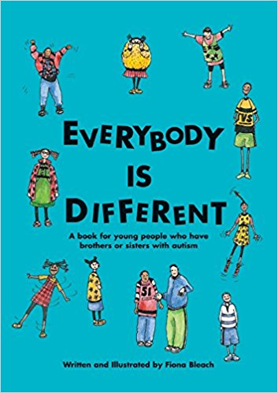 | Everybody is Different: A Book for Young People Who Have Brothers or Sisters with Autism, Fiona Bleach  This book gives answers to the many questions brothers and sisters of young people on the autism spectrum have about their siblings. In addition to explaining in basic terms the characteristics of autism, this little book is full of helpful suggestions for making family life more comfortable for everyone.
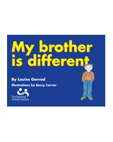 | My Brother is Different - A book for young people who have brothers and sisters with autism, Louise Gorrod & Beccy Carver for the National Autistic Society  Written by a mother of a child with autism and beautifully illustrated in full colour, this book explains the behaviour of a child with autism in terms that young siblings will be able to understand, enabling them to deal both practically and emotionally with their brother/sister. This book is aimed at younger siblings aged 4-7.
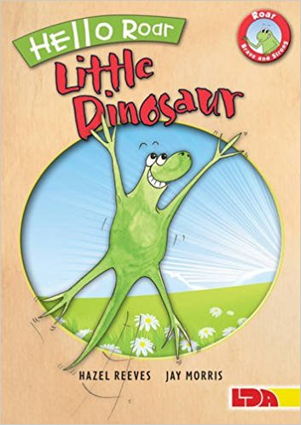 | Hello Roar, Little Dinosaur, Hazel Reeves & Jay Morris  This is the first title in a beautiful new series of picture books launches Roar, the brave and strong little dinosaur who knows it's okay to do things differently. Roar books and resources have been specially created to help children with high-functioning Autism/Asperger's Syndrome and those who live and work with them. Just like Roar, children with autism think in a different way. This enchanting storybook invites children, parents, carers and teachers to celebrate the strengths of children with Asperger's. Roar has many great qualities including honesty, determination, attention to detail, exceptional memory and a sense of humour. Roar helps children move from feeling, 'I've got it wrong!' to saying, 'This is me. I'm okay.' Roar is the main character in this series of books, alongside a family member and occasionally a supportive friend. She uses her special talents and likes to be busy, but enjoys taking a break by hiding - just as children with Asperger's find joining in can be hard work and like to take a break, perhaps by doing a simple activity on their own; routine and ritual restore an overloaded mind.
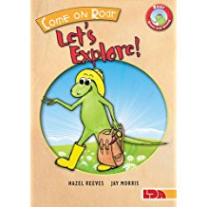 | Come on Roar, Let's Explore!, Hazel Reeves & Jay Morris  This is the second title in a beautiful new series of picture books launches Roar, the brave and strong little dinosaur who knows it's okay to do things differently. Roar books and resources have been specially created to help children with high-functioning Autism/Asperger's Syndrome and those who live and work with them. Just like Roar, children with autism think in a different way. This enchanting storybook invites children, parents, carers and teachers to celebrate the strengths of children with Asperger's. Roar has many great qualities including honesty, determination, attention to detail, exceptional memory and a sense of humour. Roar helps children move from feeling, 'I've got it wrong!' to saying, 'This is me. I'm okay.' Roar is the main character in this series of books, alongside a family member and occasionally a supportive friend. She uses her special talents and likes to be busy, but enjoys taking a break by hiding - just as children with Asperger's find joining in can be hard work and like to take a break, perhaps by doing a simple activity on their own; routine and ritual restore an overloaded mind.
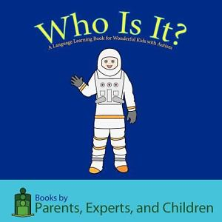 | Who is it? A Language Learning Book for Wonderful Kids With Autism, PEC Books  “Children with language delays find questions confusing and difficult to answer. Through an easy format that incorporates much needed repetition, these books provide children with the words that will help them to respond. The books give those children scripts in a colorful and interesting format that is bound to get their attention. The pictures will draw them in as the words help them to develop language skills.”  – Debra B. Crump, Special Education Consultant & Autism Information Specialist  PLEASE NOTE This book contains some American job titles that we wouldn’t usually use (Janitor instead of Caretaker, Garbage Man instead of Rubbish Man/Refuse Collector, Construction Worker instead of Builder, Mailman instead of Postman
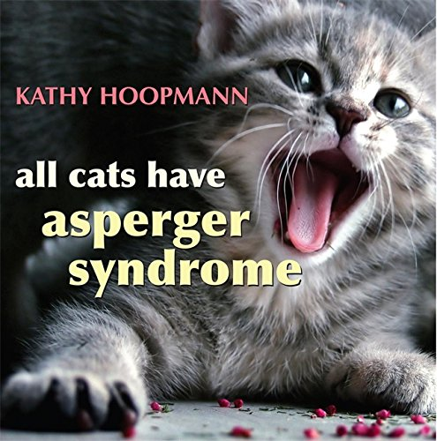 | All Cats have Asperger Syndrome, Kathy Hoopmann  All Cats Have Asperger Syndrome takes a playful look at Asperger Syndrome (AS), drawing inspiration from the feline world in a way that will strike a chord with all those who are familiar with AS.  Delightful colour photographs of cats bring to life familiar characteristics such as sensitive hearing, scampering at the first sign of being stroked, and particular eating habits.  Touching, humorous and insightful, this book evokes the difficulties and joys of raising a child who is different and leaves the reader with a sense of the dignity, individuality, and potential of people with AS.  This engaging book is an ideal, gentle introduction to the world of AS.  “There is a great deal of truth in humour. If you have only just begun to discover why someone with Asperger's syndrome is different, this book will inform and entertain you. The descriptions provide an accurate balance between the qualities and difficulties associated with Asperger's syndrome, while the photographs will make the journey of discovery enjoyable and remarkable.”  – Tony Attwood, author of Asperger's Syndrome and The Complete Guide to Asperger's Syndrome
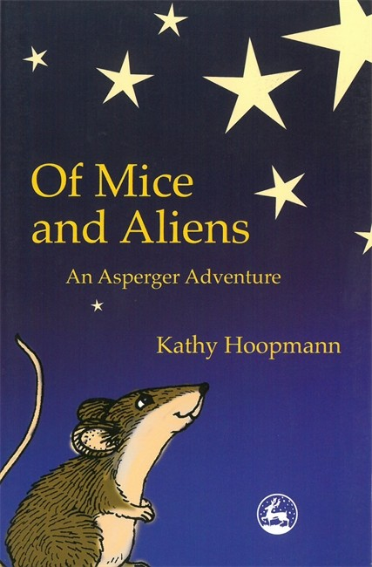 | Of Mice and Aliens: An Asperger Adventure, Kathy Hoopman  The sequel to Blue Bottle Mystery, this is a science fiction novel for kids, with a difference. Ben is learning to cope with his newly diagnosed Asperger Syndrome, but when an alien crash-lands in his back yard, things really get complicated. The alien, Zeke, knows nothing about Earth's rules and norms and it is up to Ben and his friend Andy to help Zeke survive. The humorous parallels between the alien's inability to relate to humans and Ben's own idiosyncrasies highlight the difficulties Aspie kids face every day.  Of Mice and Aliens is not just another kids' book. As well as being a delightful read for anyone who loves adventure, it is a valuable teaching tool that demystifies children with Asperger's, justifying their individuality as valid and interesting.
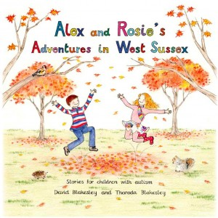 | Alex and Rosie’s Adventures in West Sussex: Stories for Children With Autism, David Blakesly & Therada Blakesly  Autism and Nature is a non-profit organisation dedicated to enriching the lives of children on the autistic spectrum, by helping to engage them with the countryside and nature. Alex and Rosie’s Adventures in West Sussex has been written to complement our guide Visiting the West Sussex Countryside: a guide for parents and teachers of children with autism. The book tells the story of two children, Alex and Rosie, who visit natural places described in our guide. We hope that it will appeal to younger children with autism and children with speech and language difficulties, and encourage their interest in the countryside and nature.
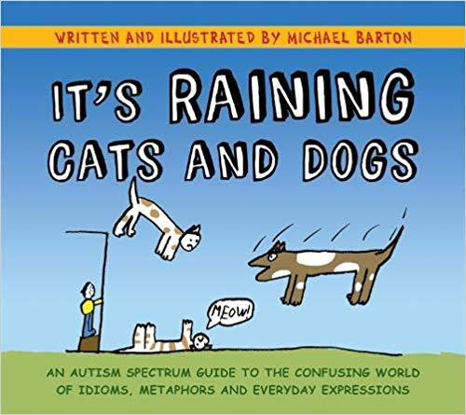 | It’s Raining Cats and Dogs: An Autism Spectrum Guide to the Confusing World of Idioms, Metaphors and Everyday Expressions, Michael Barton  The English language can be extremely confusing and illogical, especially for people with Autism Spectrum Disorder (ASD) who interpret meaning in a very literal way. Why should an announcement that cats and dogs are falling from the sky indicate heavy rain? And what have chickens got to do with being a coward?  It's Raining Cats and Dogs is a witty and stylish insight into the mind of someone with an ASD. It beautifully illustrates why people with ASD have problems understanding common phrases and idioms that others accept unquestioningly as part of everyday speech. The quirky drawings will entertain and inspire those on the spectrum, giving them the confidence to recognise figures of speech, feel less alienated and even use idioms themselves.  The drawings will form instantly memorable references for those with ASD to recall whenever they need to and will be helpful for anyone curious to understand the ASD way of thinking. They will enable people on the spectrum and their friends, families, teachers and colleagues to better understand and communicate with each other.

Signing

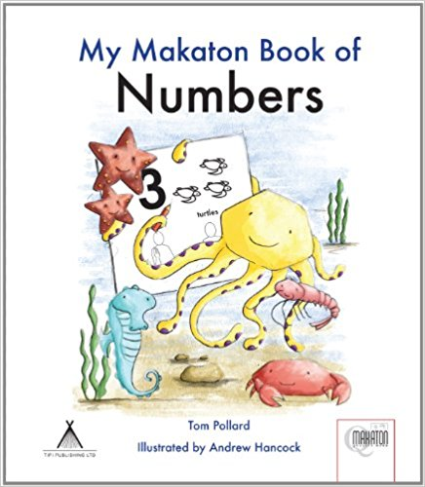 | My Makaton Book of Numbers, Tom Pollard & Andrew Hancock  Learning to count is fun with My Makaton Book of Numbers and downloadable activity sheets. Lovable illustrations of colourful sea animals are used to introduce early maths concepts. The text is enhanced using Makaton Symbols and Signs which encourage the development of essential communication and literacy skills. Makaton Symbols and Signs include; one whale, two sharks, three turtles, four penguins, five octopuses, six jellyfish, seven crabs, eight starfish, nine seahorses, ten shrimps, find and count. Instructional text and the following other useful signs are also included: number, how many, first, last, before, after, next and think. My Makaton Book of Numbers is accredited by The Makaton Charity as meeting their high standards.
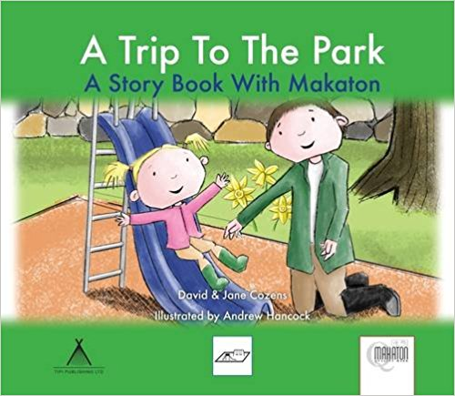 | A Trip to the Park: A Story Book With Makaton, David & Jane Cozens  This illustrated Makaton Children's Book is part of a series of short stories based on days out. In this story the children enjoy a spring day at their local park. They play on the slide, swings and roundabout before walking home at the end of the day. The text throughout the story is accompanied by signs. Using signs when reading with your child helps them develop their communication skills and follow the story. All of the stories in this series are based on getting ready, travelling, enjoying the destination and the end of the day. They are beautifully illustrated books children will love to read again and again. They are also an easy way to learn new signs and practice signing simple phrases.
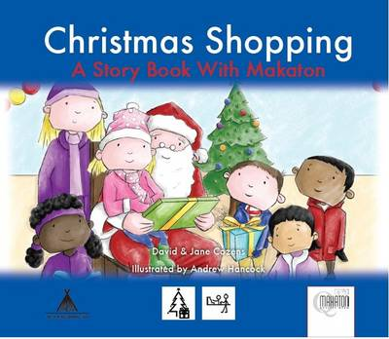 | Christmas Shopping: A Story Book With Makaton, David & Jane Cozens  This illustrated Makaton Children s Book is one of a series of short stories based on days out. In this story the Children brave the wintry weather travelling by bus to visit their favourite toy shop. They enjoy the Christmas lights and meet Santa before returning home at the end of the day. The text throughout the story is accompanied by Makaton Signs. Beautifully illustrated by Andrew Hancock your child will want to read this book again and again. It also ideal way to lean new Makaton Signs and practice signing simple phrases. Includes the following Makaton Signs to help celebrate Christmas holidays; Christmas, Christmas Cracker, Christmas Lights, Christmas Tree, Cold, Father Christmas, Gloves, Happy/ Merry, Hat, Party, Present, Shops, Sledge, Snowman, Thank you, Tinsel, Toys, Turkey.
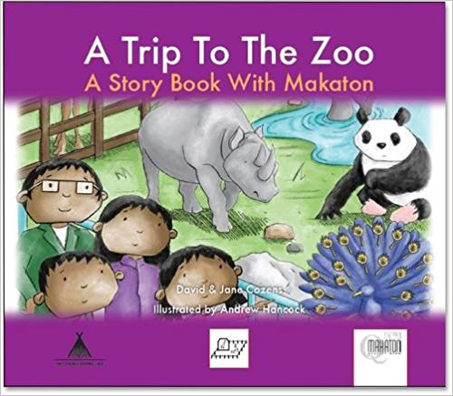 | A Trip to the Zoo: A Story Book With Makaton, David & Jane Cozens  This illustrated Makaton Children's Book is part of a series of short stories based on days out. In this story the children take a train to visit the Zoo. There they see all their favourite animals and enjoy a packed lunch before travelling home at the end of the day. The text throughout the story is accompanied by signs. Using signs when reading with your child helps them develop their communication skills and follow the story. An easy way to lean new signs and practice signing simple phrases.
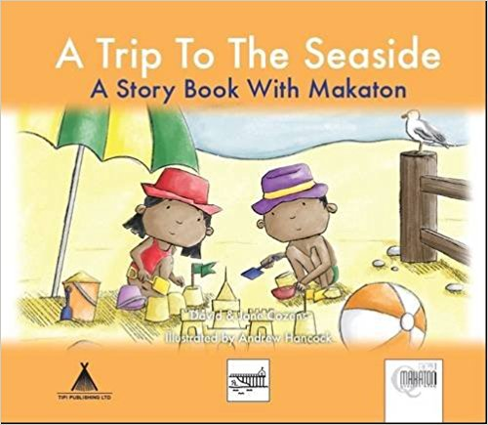 | A Trip to the Seaside: A Story Book With Makaton, David & Jane Cozens  This illustrated Makaton Children's Book is part of a series of short stories based on days out. In this story the children enjoy a summer day at the seaside building a sandcastle and playing on the beach. They have a ride on a donkey and cool off with delicious ice creams. At the end of the day they are driven home and the n get ready for bedtime. The text throughout the story is accompanied by signs. Using signs when reading with your child helps them develop their communication skills and follow the story. An easy way to lean new signs and practice signing simple phrases
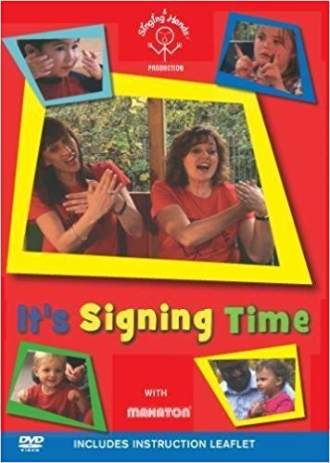 | It’s Signing Time DVD – by Singing Hands  Our first DVD features a collection of songs taken from our classes and our CDs and songbooks. You’ll see us down at the farm singing Baa Baa Black Sheep and Old MacDonald and showing you lots of animal and play signs. We also visit the playground and park with friends and there are sessions with babies and toddlers. There is a great mix of simple songs with only a few signs to songs with more signs and concepts from the Makaton vocabulary programme.
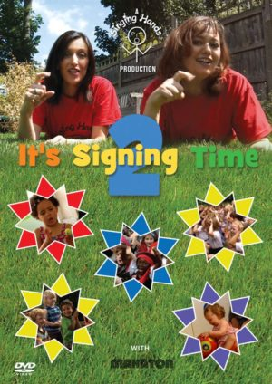 | It’s Signing Time DVD 2 – by Singing Hands  This follow-up to our popular It’s Signing Time DVD features even more signs from the Makaton Vocabulary Language Programme. This DVD will enable you and your child to learn lots of great signs for animals, transport, the alphabet, colours, numbers and many other concepts in a fun and engaging way. Produced in association with the Makaton Charity, this DVD includes some of our favourite songs about pirates, scarecrows, the weather and so much more. Come and join us singing on our big red bus, at school, at nursery and marching round the park!
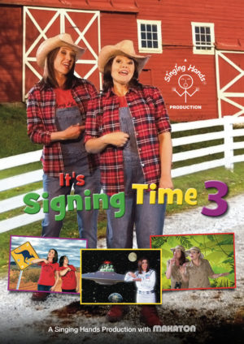 | It’s Signing Time DVD 3 – by Singing Hands  We’re back again with a collection of Makaton-signed songs for you to enjoy! This DVD will enable you and your child to learn lots of great signs for emotions, animals, transport, the alphabet, colours, numbers and many other concepts in a fun and engaging way. Produced in association with the Makaton Charity, this DVD includes some of our favourite new songs sung on location at the Zoo, in a school and at the Fire Station plus zany songs about aliens, kangaroos, crocodiles and much more.

