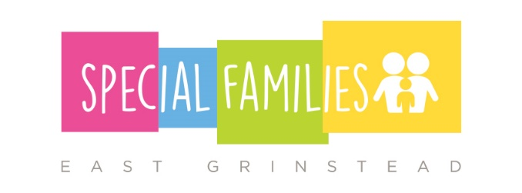
SFEG SENSORY LIBRARY – list of items

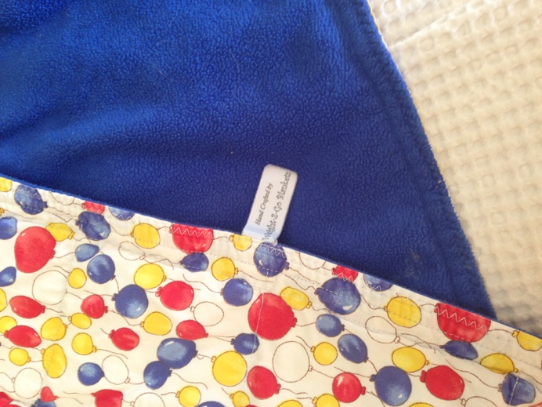
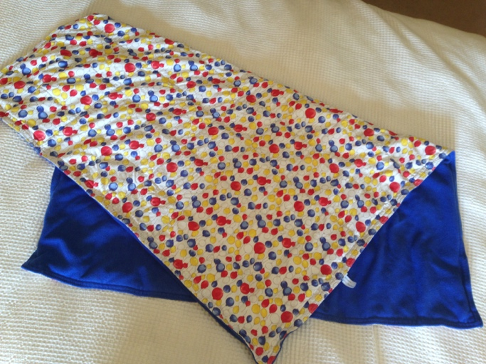
1. Weighted blanket

Size: 40 inches by 48 inches
Recommended weight = 10% of child’s body weight + 0.5 to 1kg (or less, but not more)
Child must not have mobility issues and must be well supervised.

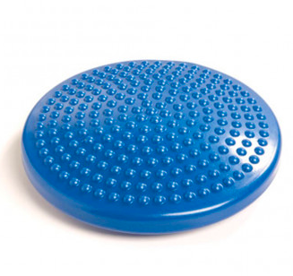
2. Round wobble cushion
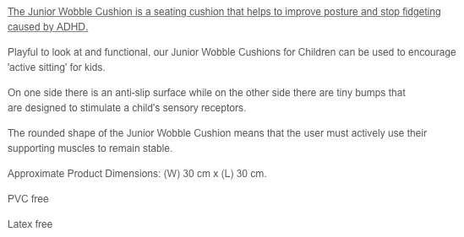

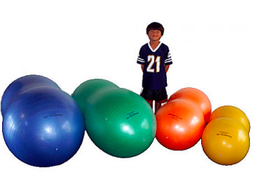
3. Anti-burst peanut ball (45cm)

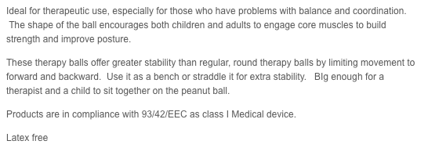

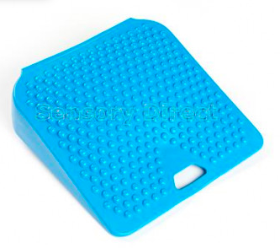
4. Movin’ Sit wedge cushion (junior)

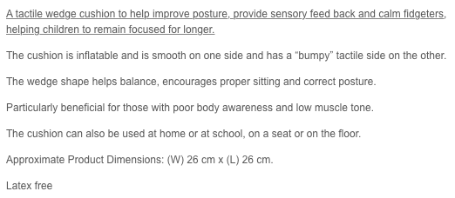

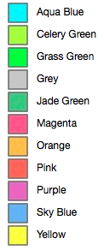
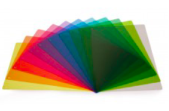
5. Coloured overlays (full set)

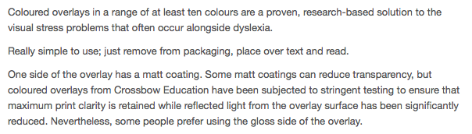

6. Writing slope
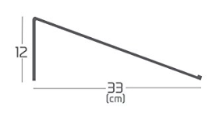
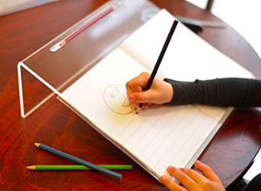

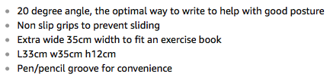

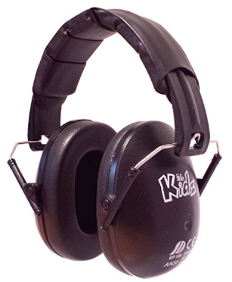
7. Ear defenders

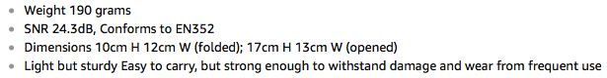

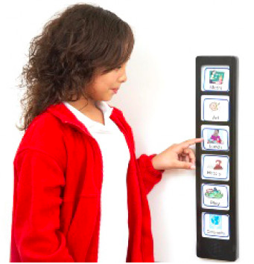
8. Recordable visual timetable

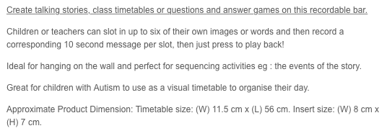

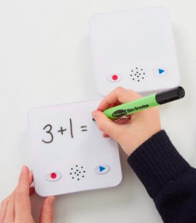
9. Recordable sound bank

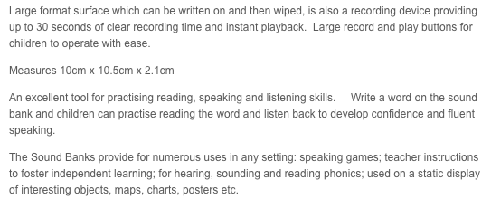

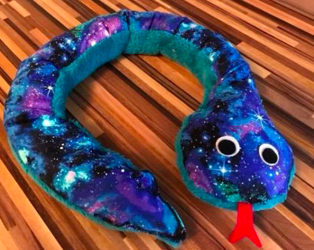
10. Weighted snake

Weight: approx. 1.3kg
Length: approx. 1m

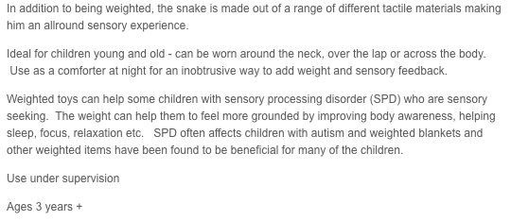

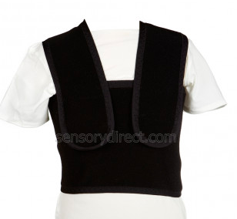
11. Compression waistcoat (size M)

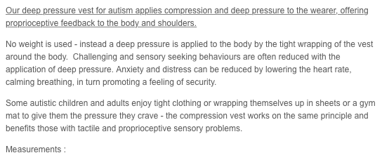

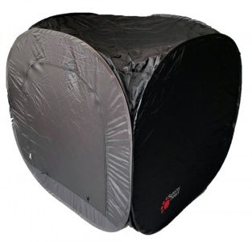

12. Pop-up blackout tent

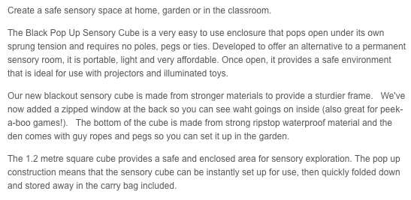

The Special Families sensory library is free of charge for members. Please make sure that you have supplied us with your contact details before borrowing for the first time.

To arrange collection or return, please contact us via the group Facebook page or directly to Alice Lily at email address alicelily1@yahoo.co.uk .

Item:

Date of return:

Name: ______________________________________________________

Address: ______________________________________________________
______________________________________________________
______________________________________________________

Phone(s): ______________________________________________________

Email: ______________________________________________________

I agree that the use of this item is entirely at my own risk, and that Special Families East Grinstead is not held responsible for the item and its effects. I will endeavour to keep the item in reasonable condition and return it on time. I confirm that I agree to my details being used for the administration of the Sensory library only. Special Families East Grinstead will not share your details with any third parties.

Signed: ______________________________________________________

Print name: ______________________________________________________

